TESSA EASTMAN

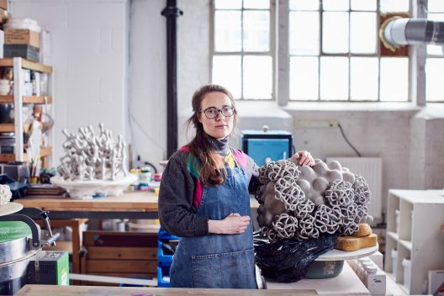
Creativity and innovation sit at the heart of Eastman’s artistic practice and collectors are drawn to the originality, skill and the daring approach she brings to ceramic art. Building pieces by hand, she draws inspiration from organic form as seen through a microscope or in the skies. She explores the strangeness of growth of natural phenomena in which systems flow and digress from an intended pattern. Eastman’s playful aesthetic lends itself to the abstract cloud-like formations or curious and ambiguous sea-like creatures that appear to inhabit her work.

Born
1984 London

Education
2013–15 MA Ceramics & Glass, Royal College of Art, London
2003-06 BA (Hons) Ceramics, University of Westminster, London

Awards
2018 Ceramics Art + Perception Magazine Writing Prize, Bridging the Divide: The Poised Sculpture of Tessa Eastman by Ashley Thorpe
2018 Shortlisted for the Carter Preston Prize, Bluecoat Display Centre, Liverpool
2017 Member of the Royal Society of Sculptors
2017 Shortlisted for the Young Masters Maylis Grand Ceramics Prize, with the Cynthia Corbett Gallery, UK and USA
2017 Honourable Mention, Gyeonggi International Ceramic Biennale, Korea
2016 London Creative Network Professional Development Programme
2016 Craft Emergency Award, Aspex Gallery, Portsmouth

Selected Exhibitions
2021 Crafting a Difference, Ting Ying Gallery, Argentine Ambassador’s Residence, London UK
2021 Pik’d Gallery Collab, Walls House of Art, Abidjan Côte d’Ivoire West Africa
2021 Crafting a Difference, Ting Ying Gallery, SoShiro, London UK
2020 Focus/20, Ting Ying Gallery, Design Centre Chelsea Harbour, London UK

2020 Reopening, Jason Jacques Gallery, New York USA
2020 Cure3, Bonhams, London UK
2020 Ode to Clay, Jason Jacques Gallery, New York US
2020 Retrospective, Galerie de l’Ancienne Poste, Toucy France
2019 Cloudspotting, Jason Jacques Gallery, New York, USA
2019 The disorder in delight of the imagination, Galerie de l’Ancienne Poste, Toucy, France
2019 Collect, with the Cynthia Corbett Gallery, Saatchi Gallery, London
2018 Still Lifes / Present & Collect, Contemporary Applied Arts
2018 New Member Showcase, Contemporary Applied Arts, London
2018 Art New York, Cynthia Corbett Gallery, New York, USA
2018 Collect, Saatchi Gallery, London
2018 Milan Design Week, Salone del Mobile, Nilufar Gallery, Milan Italy
2018 Art Boca Raton Contemporary Art Fair, Steidel Contemporary, Boca Raton, Florida, USA
2018 Art Wynwood, Cynthia Corbett Gallery, Florida, USA
2018 Contemporary Ceramics Auction, Paddle8, New York, USA
2018 Art Palm Beach, Steidel Contemporary, Florida, USA
2017 Collect, Saatchi Gallery, London
2017 Art Miami, Cynthia Corbett Gallery, Florida, USA
2017 Vigorous Form, Unit 9 Gallery, London
2017 Holiday House, FBC London, London
2017 Tresor Contemporary Craft, Puls Gallery, Basel, Switzerland
2017 Cracked, 50 Golborne Gallery, London
2017 Young Masters Prize, Cynthia Corbett Gallery, London
2017 Gyeonggi International Ceramic Biennale, Korea
2017 Pour Me, Devon Guild of Craftsmen, Devon
2017 Puls Contemporary Ceramics, Puls Gallery, Brussels, Belgium
2016-17 Craft Emergency, Aspex Gallery, Portsmouth
2015 British Ceramics Biennial, Spode Factory, Stoke-on-Trent
2015 Rupert Cavendish Antiques, London

Selected Publications
2021 Contemporary British Ceramics; beneath the surface, Ashley Thorpe, Crowood Press
2020 Special Effect Glazes, Linda Bloomfield, The New Ceramics, Bloomsbury Publishin
2020 het grote K boek 3, Mels Boom, De kleine K, The Netherlands
2019 Colour in Glazes, Linda Bloomfield
2017 Gyeonggi International Ceramic Biennale, Korea Ceramic Foundation
2012 Tradition & Innovation: Five Decades of Harrow Ceramics, foreword by Alun Graves, edited by Tessa Peters, University of Westminster

Collections
KOCEF Korea Ceramic Foundation, Korea
Gresham Private Equity, London
Abacus plc
Bryanston Association, Dorset

