JULIETTE BIGLEY

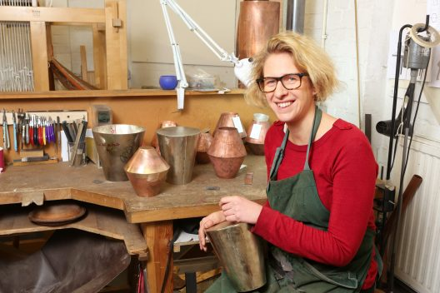
Artist-metalsmith Juliette Bigley uses the vessel-form as a canvas through which to consider how we negotiate our emotional and physical place in the world. She is particularly interested in exploring the threshold that lies between the intangible world of emotion, belief, thought, language and memory, and the physical and tangible world in which we play out our lives.

Trained at The Cass School of Art, she exhibits regularly both nationally and internationally and has work in private and public collections, including the V&A and the Irish State Collection. A regular speaker about making and its role in society, writing is an inherent part of her practice. Bigley has recently produced a publication, Material Perspectives, funded by Arts Council England. She is a Fellow of the Royal Society of Arts.

Born
1978 Sheffield

Education
2015 MA (Research), Silversmithing: Distinction, The Cass School of Art, Architecture and Design, London
2013 BA (Hons) Silversmithing, The Cass School of Art, Architecture and Design, London
2010 BTech Level 1, Kensington and Chelsea College
2002 MSc Voluntary Sector Policy, London School of Economics
2001 MA, English Literature, University of Edinburgh

Awards
2018 Collect Open Award, Collect Awards
2017 Arts Council England, Grants for the Arts funding award
2016 Silver Trust Award for a Body of Work
2016 Silver and Bronze Awards, 3D Design, Goldsmiths Craft and Design Council
2015 Special Mention, Goldsmiths’ Fair, The Goldsmiths’ Company
2015 Design Council ‘Ones to Watch’ for potential to contribute to British Design
2014 Gil Packard Bursary, Goldsmiths Craft and Design Council
2014 Society of Designer Craftsmen Distinction Award
2013 The Cass Award for Excellence
2011 Simon Benney Award
2011 British Jewellers Association Award for Silversmithing
2011 Argex Award for a Body of Work
2011 Centrepunch Award for a Body of Work
2011 The Cass Award for Excellence

Selected Exhibitions
2021 Artefact, Chelsea Harbour, London with Metal Collective
2021 Mastery: Women in Silver, Ruthin Craft Centre
2019 Solo exhibition: Further Material Perspectives, Scottish Gallery, Edinburgh
2019 FPS London Ultra, Bargehouse
2019 Gallerie Montan, Copenhagen
2019 Collect International Fair for Contemporary Objects
2019 August Brandt
2018 Opening Narratives, Hauser & Wirth Make, Bruton, Somerset
2018 Homo Faber, Michael Angelo Foundation, Venice
2018 Galerie Handwerk, Munich
2018 Collect: Collect Open exhibiting TABLE funded by Arts Council England, winning Collect Open Award
2018 Cosmima, London
2017 Design Miami with Sarah Myerscough, Miami, USA
2017 Metal Project at Tresor, Basel
2017 Art Geneve, with Taste Contemporary, Geneva (also 2014 and 2016)
2016 A Future Made International Showcasing Programme
2016 Silver Speaks at the V&A
2016 Future Heritage at Decorex
2016 Roger Billcliffe Gallery (from 2013)
2016 Bluecoat Display Centre; Aram Gallery, London; Cambridge Contemporary Art
2016 Design Days Dubai
2016 Meister der Moderne (Modern Masters), Handwerkmesse, Munich

Selected Publications
2018 Material Perspectives, Juliette Bigley

Collections
Irish State Collection, Dublin
Victoria and Albert Museum, London

